FAA Simulator Pro Instruction Manual
Prateek Tandon & Henry Yuen

- Purpose

The FAA Simulator Pro is meant to provide a training ground for Air Traffic Controllers (ATCs). The job of an ATC is not easy. Not only must they ensure the normal day-to-day functioning of an airport, they must continuously watch for any possible risks that may occur. Our software simulates key scenarios that may arise on a given airport. ATCs will be thrust into the scenario and must find ways to manage the airport without it blowing up. We hope this is good training for real life.

WARNING: DO NOT RUN THIS ON ALUDRA AT ALL COSTS.
Many features that we support such as text to speech won’t be present when you run it on aludra.

- How to Use Our System

1. Run “run.gui” target from the build.xml file (either via command line or through eclipse).

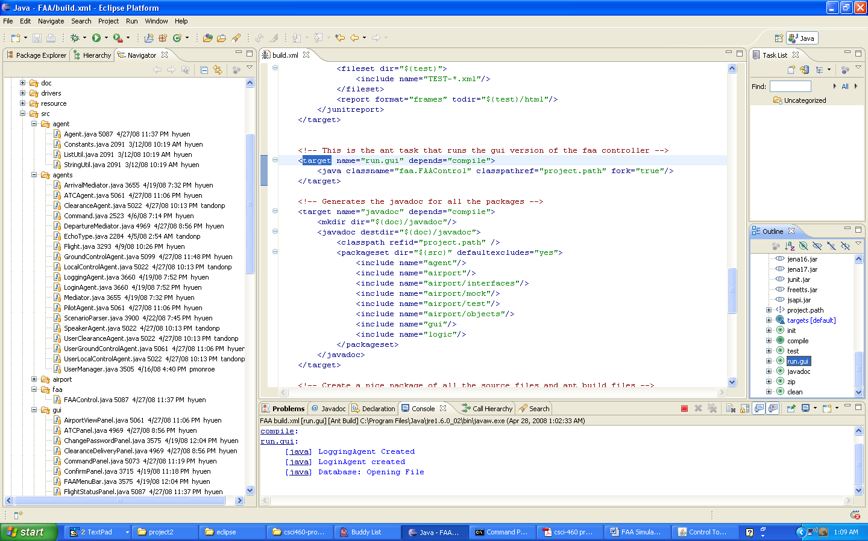

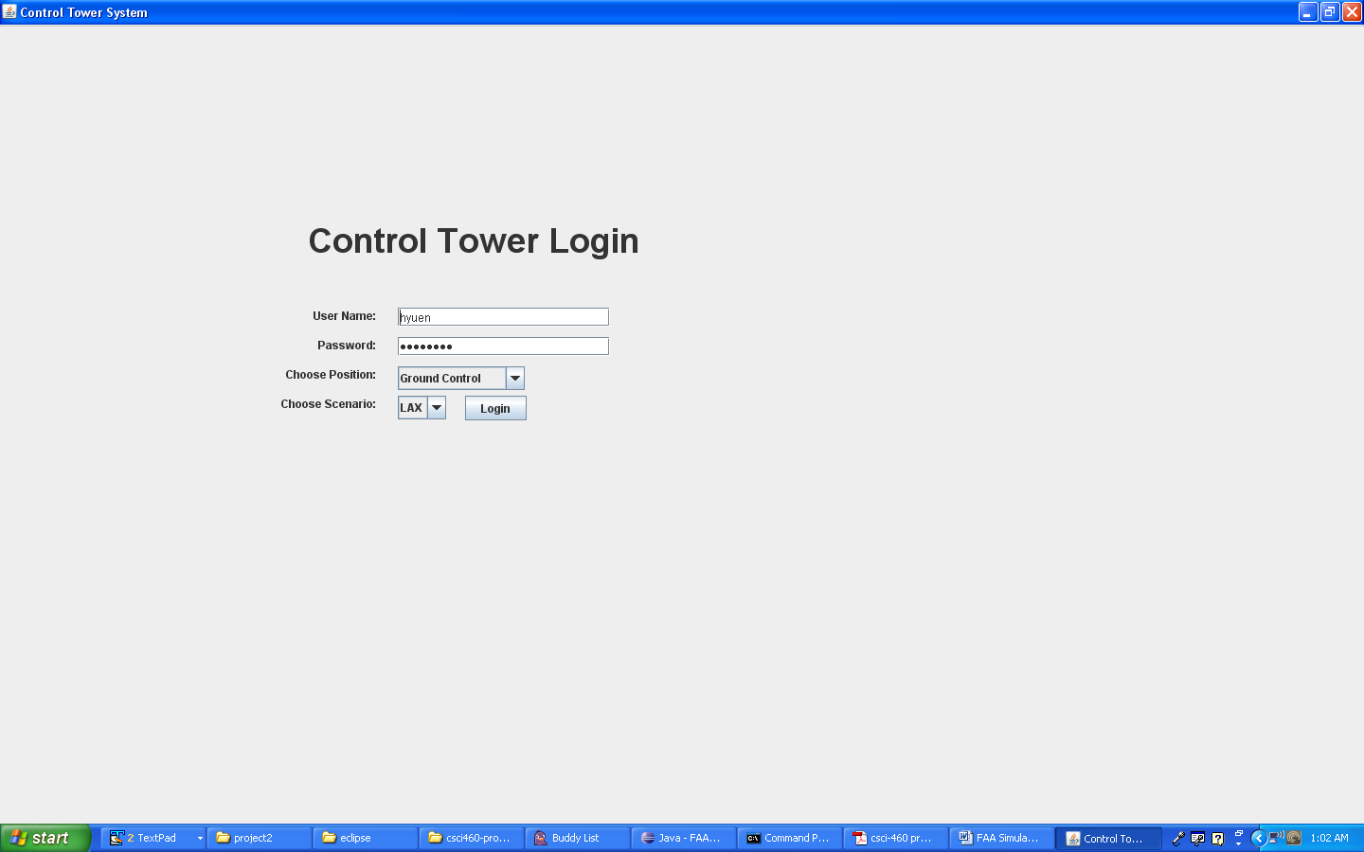

  - ATCs will start off at the login screen. The default username/password combination is hyuen/password. A person can login as a ground controller, a local controller, a clearance delivery agent, or the supervisor. Hit login and enjoy the magic. Let’s use logging in as ground controller as an example.

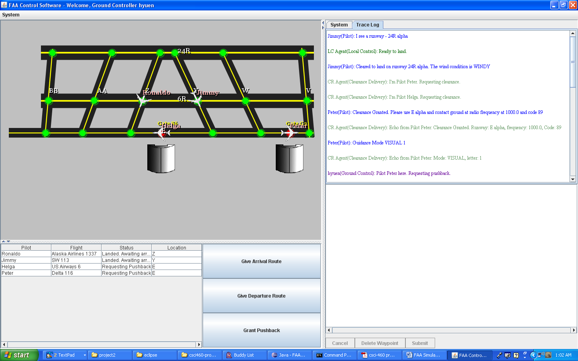

3. Immediately when you login, you will be thrust into the “real world” of air traffic communication. Pilots will be asking for all sorts of requests which you must fulfill. As a ground controller you can give arriving pilots routes to gates, departing pilots routes to the runway, and grant pushback to planes that require taxing. The full screen of the trace of the communications is available.

To issue a command to a pilot, highlight a pilot from the JTable and press a button. Pilot requests will come in asynchronously. Confirm them when they come. Of course, you can always be mean and not do it. But then you might lose your job so it’s probably not good training.

III. Testing Our System

Running the unit tests in our system is quite easy. Simply run the following functions at the command line:

ant clean
ant compile
ant test

Which will run the entire test suite. Please be patient – some unit tests might take a while.

